**Experiment 2.1**

--------------------

` This report describes work done to understand the response characteristics of a simple RC variant of the low pass filter. To this end a circuit was constructed consisting of a one kilo ohm resistor connected in series to a one Hebdo Farad capacitor. An NI myDAQ was used to generate and send a signal to the circuit to determine its response characteristics.

A schematic was designed and validated in KiCad. The design for the simple filter is shown here. Hopefully, the schematic works out. It passed tests in KiCad. It looks a little different from the traditional hand drawn schematic.

***Fig. 1.1*** circuit schematic.

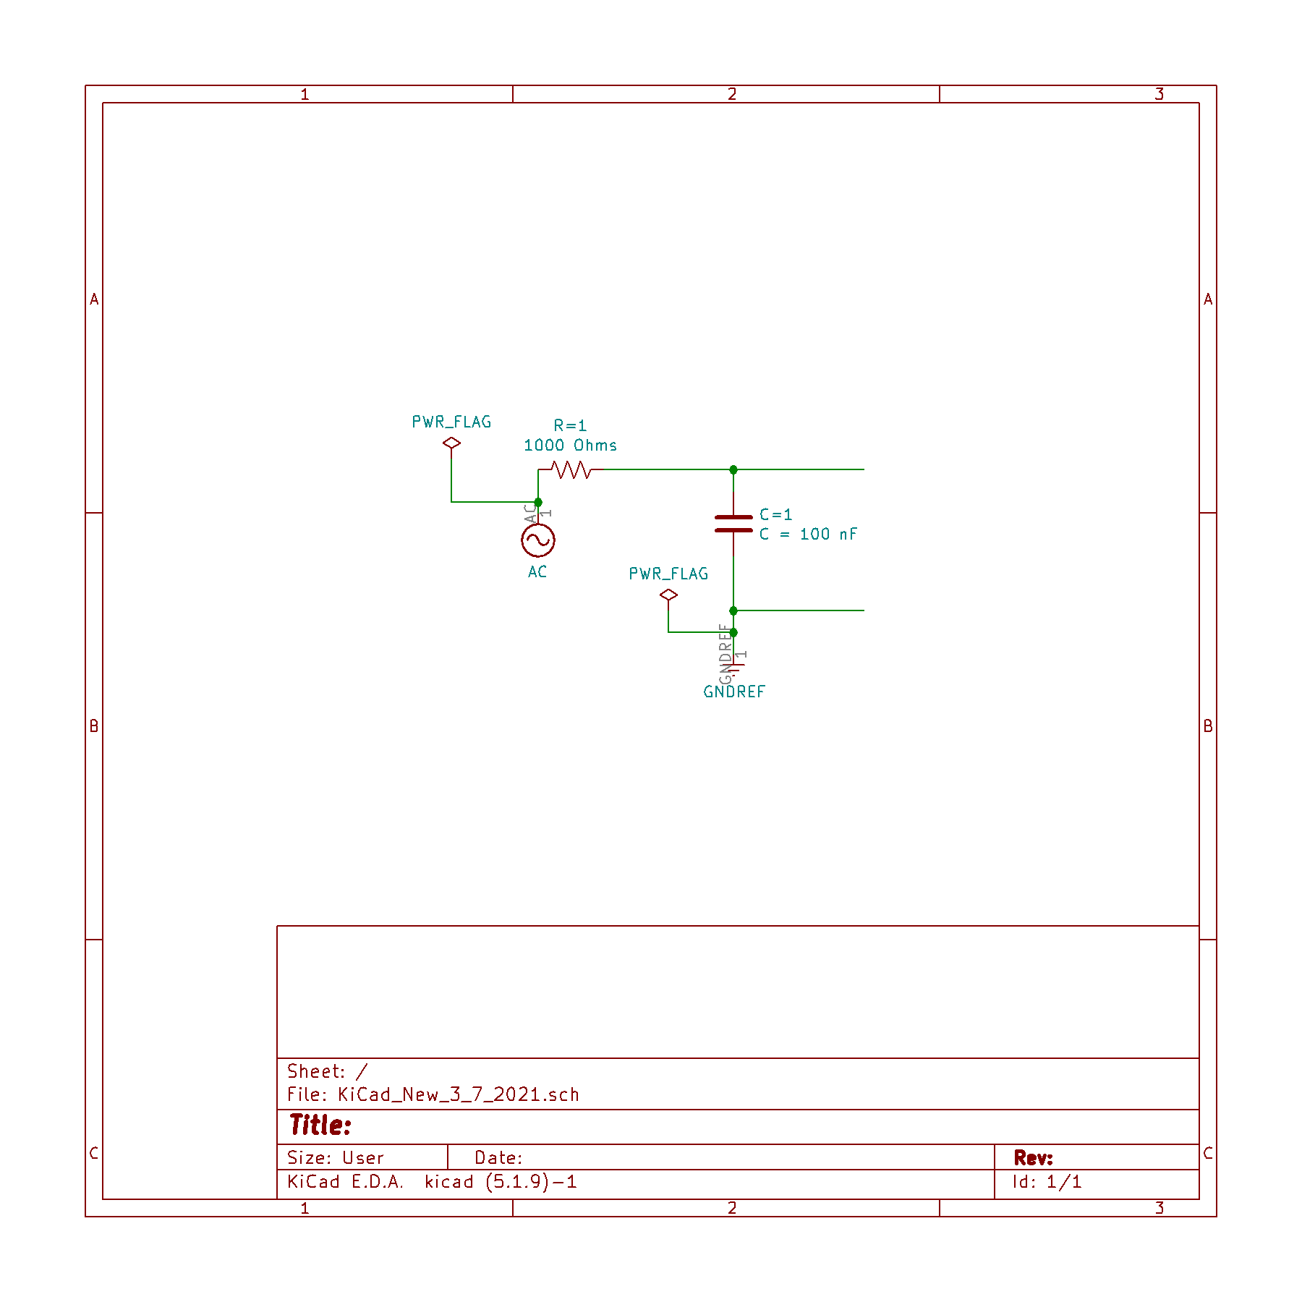

***Image 1.1 (Resistor - Capacitor)***

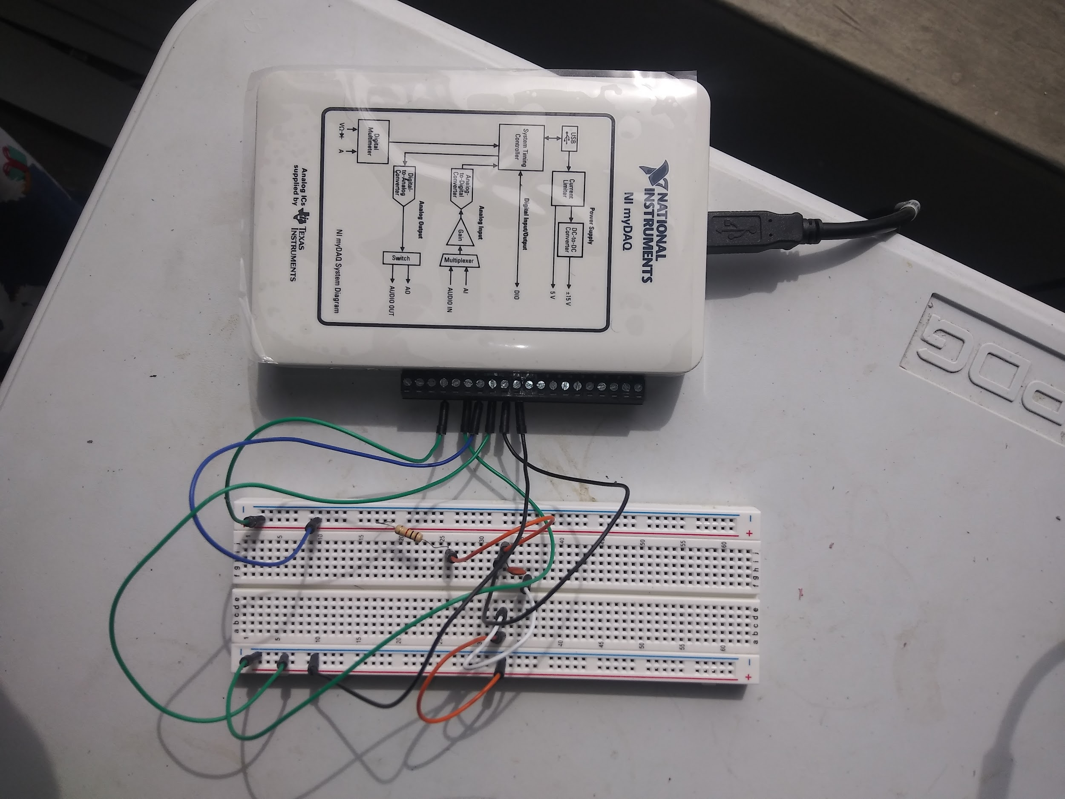

**Notes on the actual implementation.**

The implementation is a little different from what was shown in the schematic. However both can be proven to be topologically equivalent. An NI myDAQ was used to supply power to the circuit, and to collect data from it. A sinusoidal power pulse was emitted from the supply from AO0. A lead was connected from AO0 to one of two positive rails on the breadboard. The board was grounded by connecting a lead from AGND on the AI section of the DAQ. The opposite end of this lead was then connected to the negative rail on the other side of the diving trench. The continuity of the circuit was implemented by connecting a bridging jumper lead connecting both subdivisions of the breadboard. The left and the right divisions.

An important remark is that 6 leads were connected to the DAQ. These leads mirror the processes required for the experiment. These are sending a pulse from the DAQ, measuring the pulse before it interacts with the signal, and measuring the effect after the interaction. This

**Predictions:**

The corner frequency should be just about the inverse of the product of twice the product of pie by characteristic time of the circuit. This was calculated to be 1592.35666Hz. The phase at this frequency is predicted from theory to be about 45 degrees.

**Data Collection and Analysis:**

Data was collected through a Bode Analyzer. The Bode Analyzer registers the response of the circuit over different frequencies. The gain was logged, plotted and fitted to predict the response at the theoretical corner frequency.

Amplitude: 2.00 V

Freq (Hz) Gain (dB) Phase (deg)

100.000 -0.039 -3.657

104.713 -0.042 -3.836

109.648 -0.044 -4.011

114.815 -0.047 -4.121

120.226 -0.050 -4.374

125.893 -0.054 -4.506

131.826 -0.058 -4.710

138.038 -0.062 -5.005

144.544 -0.066 -5.154

151.356 -0.070 -5.466

158.489 -0.076 -5.719

165.959 -0.081 -5.979

173.780 -0.087 -6.172

181.970 -0.093 -6.548

190.546 -0.100 -6.853

199.526 -0.108 -7.164

208.930 -0.116 -7.493

218.776 -0.125 -7.714

229.087 -0.134 -8.219

239.883 -0.145 -8.440

251.189 -0.156 -8.956

263.027 -0.168 -9.365

275.423 -0.181 -9.788

288.403 -0.195 -10.073

301.995 -0.210 -10.676

316.228 -0.227 -11.175

331.131 -0.245 -11.622

346.737 -0.264 -12.140

363.078 -0.285 -12.683

380.189 -0.309 -13.094

398.107 -0.334 -13.685

416.869 -0.360 -14.446

436.516 -0.389 -15.151

457.088 -0.420 -15.745

478.630 -0.455 -16.448

501.187 -0.493 -16.956

524.807 -0.533 -17.692

549.541 -0.577 -18.689

575.440 -0.623 -19.470

602.560 -0.673 -20.288

630.957 -0.727 -21.135

660.693 -0.787 -22.038

691.831 -0.850 -23.113

724.436 -0.918 -23.576

758.578 -0.991 -24.851

794.328 -1.066 -25.852

831.764 -1.153 -26.846

870.964 -1.244 -27.911

912.011 -1.337 -28.945

954.993 -1.441 -30.052

1000.000 -1.550 -31.298

1047.129 -1.664 -32.281

1096.478 -1.791 -33.464

1148.154 -1.918 -34.609

1202.264 -2.060 -35.828

1258.925 -2.205 -37.012

1318.257 -2.364 -38.265

1380.384 -2.525 -39.476

1445.440 -2.699 -40.728

1513.561 -2.873 -41.921

1584.893 -3.063 -43.173

1659.587 -3.262 -44.428

1737.801 -3.471 -45.267

1819.701 -3.681 -46.898

1905.461 -3.897 -48.091

1995.262 -4.134 -49.340

2089.296 -4.367 -50.521

2187.762 -4.617 -51.735

2290.868 -4.863 -52.872

2398.833 -5.130 -54.059

2511.886 -5.393 -55.170

2630.268 -5.676 -55.301

2754.229 -5.949 -57.375

2884.032 -6.227 -58.405

3019.952 -6.521 -59.451

3162.278 -6.823 -60.478

3311.311 -7.135 -61.531

3467.369 -7.441 -62.482

3630.781 -7.753 -63.411

3801.894 -8.072 -64.317

3981.072 -8.402 -65.233

4168.694 -8.728 -66.072

4365.158 -9.055 -66.884

4570.882 -9.389 -67.677

4786.301 -9.726 -68.440

5011.872 -10.069 -69.185

5248.075 -10.429 -69.939

5495.409 -10.777 -70.631

5754.399 -11.125 -71.285

6025.596 -11.473 -71.914

6309.573 -11.837 -72.540

6606.934 -12.181 -73.099

6918.310 -12.553 -73.690

7244.360 -12.914 -74.235

7585.776 -13.273 -74.744

7943.282 -13.635 -75.201

8317.638 -14.003 -75.710

8709.636 -14.369 -76.161

9120.108 -14.743 -76.604

9549.926 -15.103 -76.996

10000.000 -15.489 -77.623

***NI image 1.1 :***

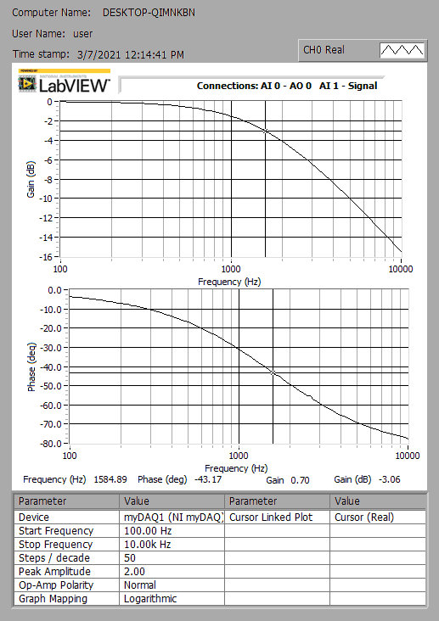

A log-linear plot of the phase vs the frequency is shown above. The y axis is the Phase and the abscissa is the log of the frequency. The plot below is a matlab plot of the phase vs frequency of circuit response.

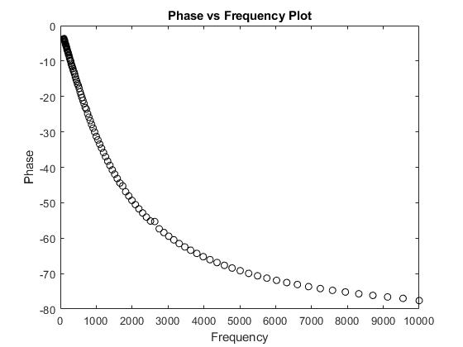

***Plot 1 :***

Intuitively, the data can be seen to almost follow the upper half of inverse x or the exponential function. The exponential function was used to fit the curve. The form of the function used was f(x) = a*exp(b*x). The fit was tightened with 95% confidence bounds over values of a = -24.5 (-27.76, 21.24), and b = 0.00148 (0.001263, 0.0001697) using matlab.

The value of the phase at the corner frequency was calculated with this specified function to be around 31 degrees. The nearest data point to the corner frequency puts the phase to near 41 degrees, and the theoretical value is 45 degrees. It can be reasoned that data interpolation about this point will leave us at around the bullseye offset* of 45 degrees.

**Experiment 2.3**

--------------------

For this experiment, the setup and procedure mirrors carefully the previous experiment. The difference is the location of the resistor and capacitor in the circuit have been flipped. The circuit configuration is of the form shown below.

***fig 1.2***

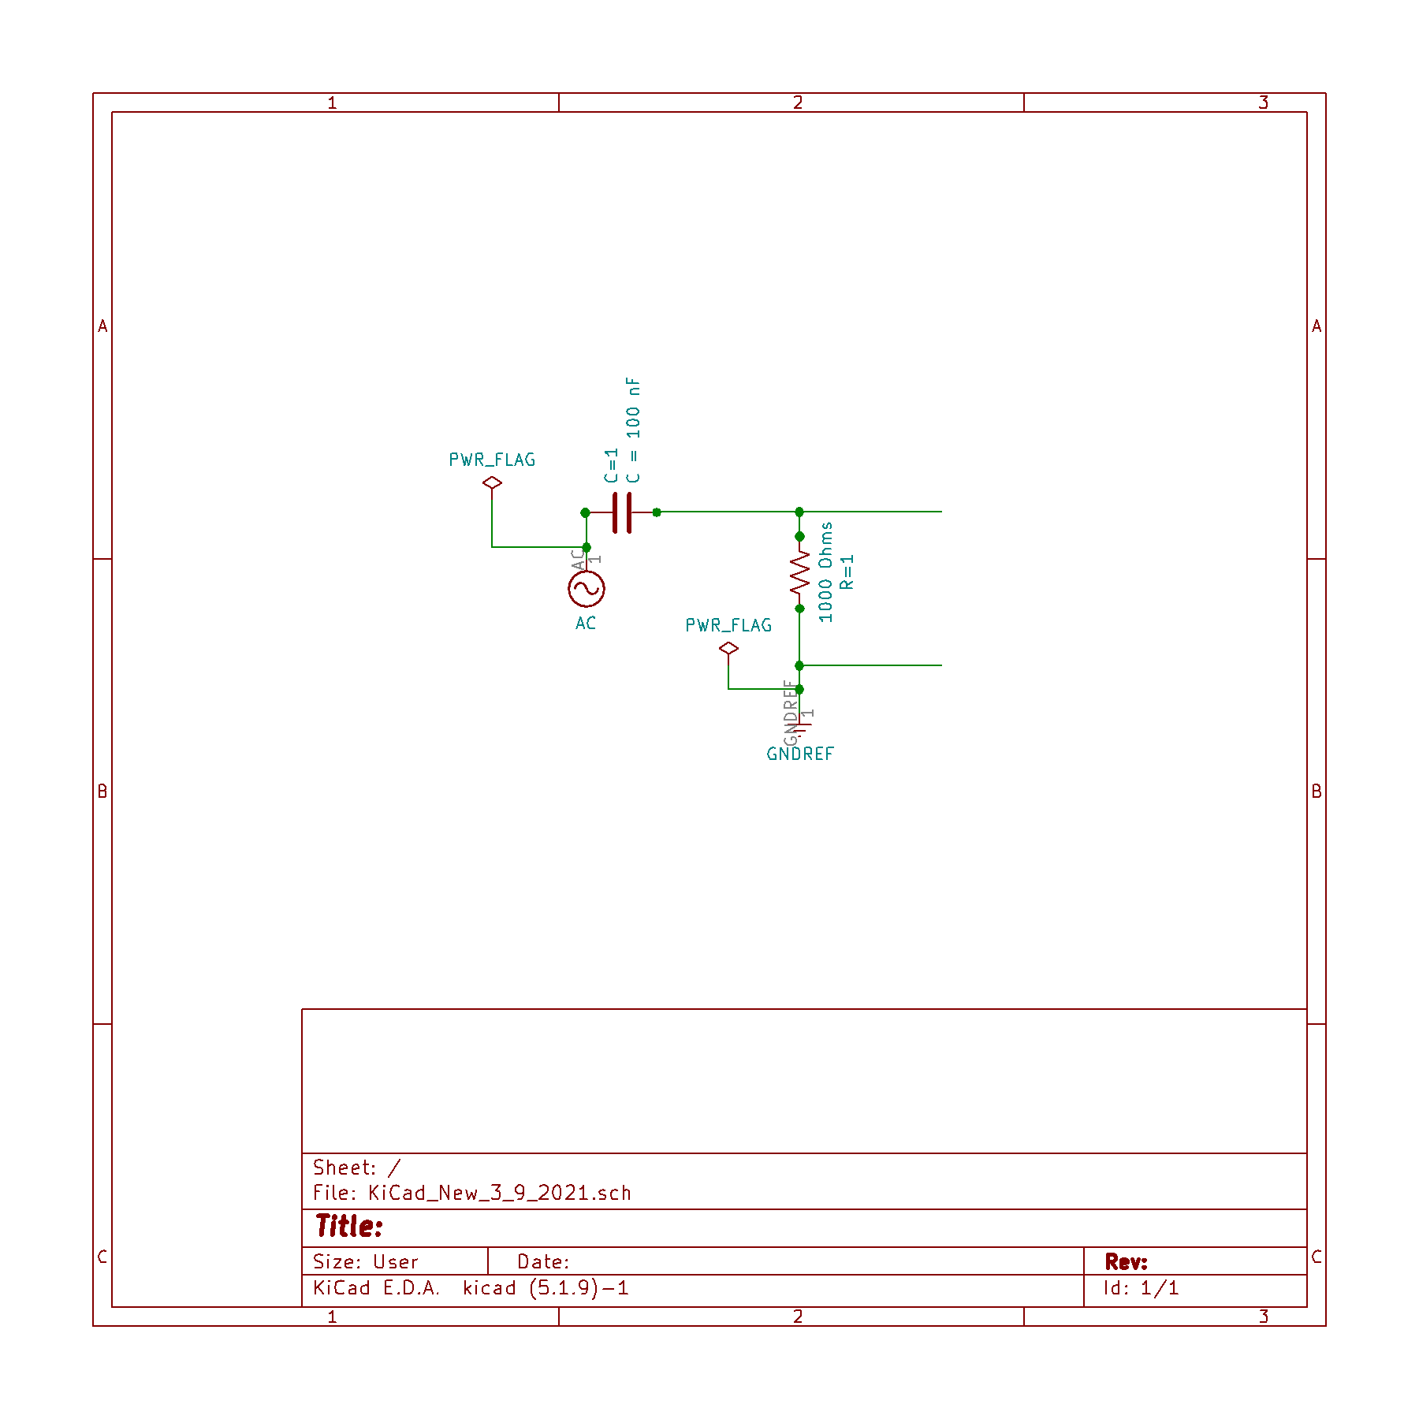

***Image 1.2 (Capacitor-Resistor)***

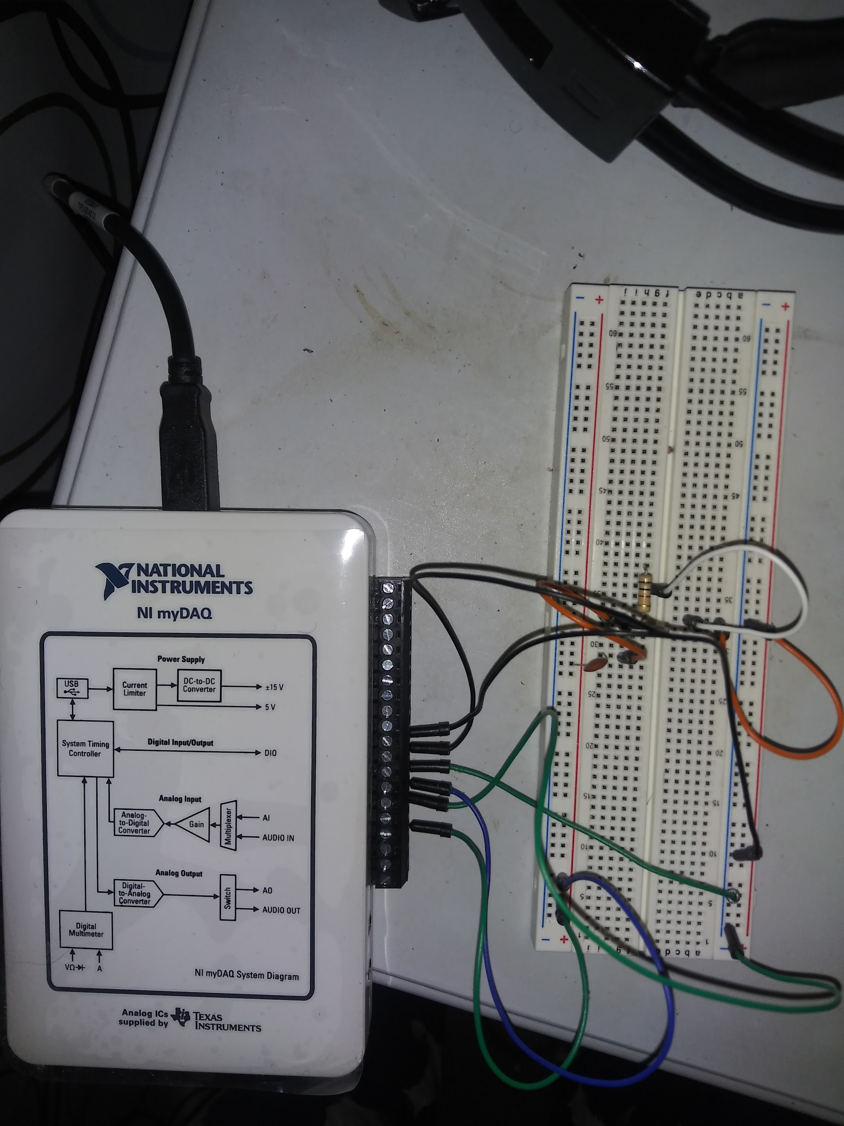

The bode analyzer was used to find a phase offset of about 45 degrees. Data was collected at 5 steps per decade.

3/9/2021 4:33 PM

Amplitude: 2.00 V

Freq (Hz) Gain (dB) Phase (deg)

100.000 -23.520 81.214

158.489 -19.526 80.227

251.189 -15.688 77.541

398.107 -11.943 72.877

630.957 -8.488 65.307

1000.000 -5.480 54.777

1584.893 -3.095 43.106

2511.886 -1.600 31.230

3981.072 -0.782 21.409

6309.573 -0.381 14.215

10000.000 -0.251 2.753

A similar fit could be made exploiting symmetry arguments on the former fit function but it seems this argument is not just trivial but obvious. What is shown from the plot is that this data is very close to what the calculation predicts.

***NI image 1.2 :***

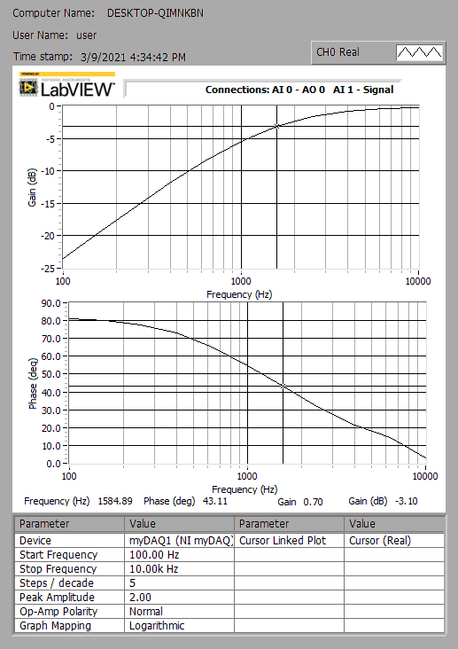

**Conclusions:**

The corner frequency of two simple filters was observed to yield a phase offset close to 45 degrees; the predicted offset. The offset was similar up to sign but differed as expected from physics. The design of the circuit was loosely filled in the implementation subject to breadboard constraints. However jumper wires assured that the designed circuit and the implemented circuit were topologically the same.